Task 1.

Write an SQL query to fetch “FIRST_NAME” from Worker table using the alias name as <WORKER_NAME>.

##select firstname as worker_name from worker_data2

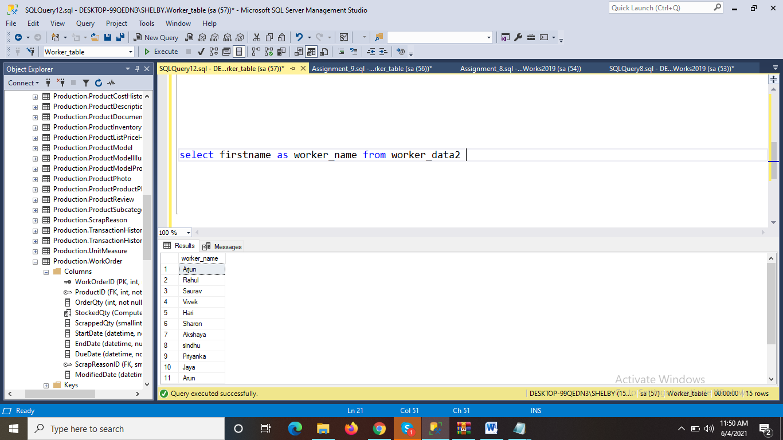

Task 2-

Write an SQL query to fetch unique values of DEPARTMENT from Worker table.

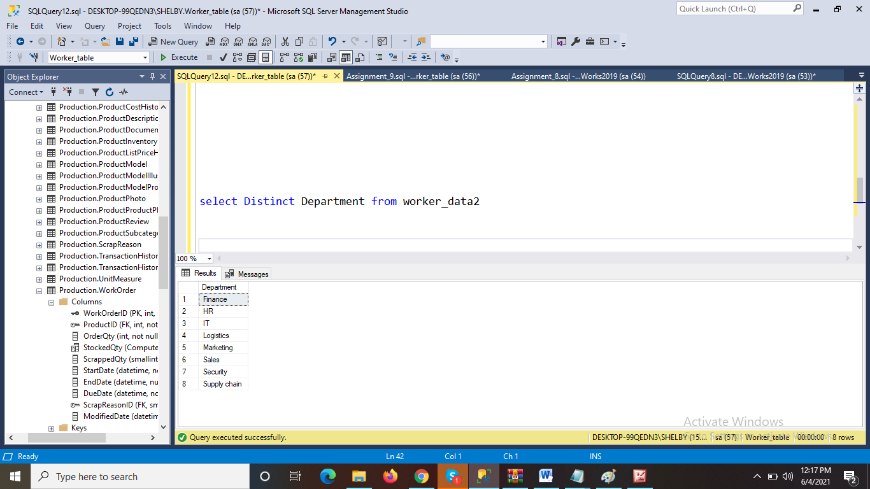

Task 3- Write an SQL query to show the last 5 record from a table.

